**INDIVIDUAL ASSIGNMENT**

**TECHNOLOGY PARK MALAYSIA**

**BM050-3-3-IMNPD**

**INNOVATION MANAGEMENT AND NEW PRODUCT DEVELOPMENT**

**Chew Yong En TP064861**

**APU3F2308SE**

**HAND OUT DATE : 12 FEB 2024**

**HAND IN DATE : 09 MARCH 2024**

**WEIGHTAGE : 20%**

# Executive Summary

A concise overview of Tesla, Inc.'s innovative strategies and organizational strengths is documented. Tesla has revolutionized the automotive and sustainable energy industries. The company's growth-oriented approach, supported by aggressive marketing and strategic partnerships, has propelled its market expansion. Tesla's dedication to technology and R&D has ensured its competitive edge. With a culture of innovation and collaboration, Tesla is well-equipped to navigate challenges and drive future success. To sustain its leadership position, Tesla must prioritize risk management, continuous learning, and ongoing innovation efforts.

Table of Contents

Executive Summary 2

Company Introduction 4

Company Analysis: Innovation Characteristics 5

Growth orientation 5

Organizational heritage and innovation experience 6

Vigilance and external links 6

Commitment to technology and R&D intensity 6

Receptivity 7

Space for creativity 7

Strategy towards innovation 8

Diverse range of skill 8

Recommendations 9

Conclusion 10

**References** 11

# Company Introduction

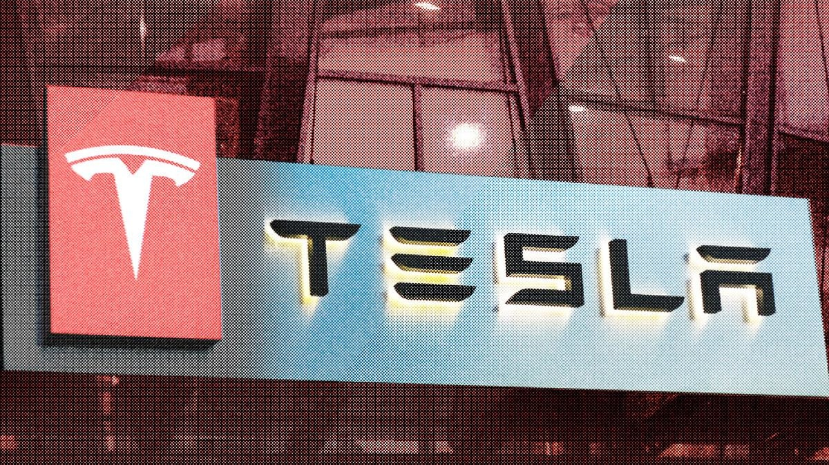

Figure 1. Tesla (Reed, 2020).

Tesla, Inc. is an American company that produces solar panels, batteries for vehicles, power storage for residences and electric vehicles (EV). Tesla was named after Serbian American inventor, Nikola Tesla and was established in 2003 by American engineers, Martin Eberhard, and Marc Tarpenning. It emerged as one of the most renowned automobile manufacturers globally (Gregersen & Schreiber, 2024). In 2008, Elon Musk had become the CEO of Tesla. Tesla's primary focus in innovation and development is directed towards exploring new business models and advancing the growth of EV technology. As the global awareness of environmental issues has increases, the consumers are increasingly showing trust in electric vehicles. The company is well-positioned for future growth as it has made substantial investments in EV production and research (Shao et al., 2021).

# Company Analysis: Innovation Characteristics

## Growth orientation

Tesla’s business strategy involves catering to high-end demand before expanding to lower-end markets (Liu & Meng, 2017), but the business is well-known now and its manufacturing costs are decreasing. Therefore, it has offered affordable options for the mid-market segment alongside high-end luxury sports cars (Qin, 2022). Tesla has maximized its revenue by aggressive marketing (Rowland, 2023). Elon Musk who has actively engages with its large social media following (60 million followers), held fan-made ad competitions to reduce advertising costs and enhance brand awareness. The figure below has shown Tesla with zero-budget advertising on social media (Shao et al., 2021).

Figure 2. Auto Brands Expenditure on Advertising (Shao et al., 2021).

Besides, Tesla progressively extends its global market presence by establishing new offices and facilities for further international expansion. Tesla has created products that attract customers as it enters new markets and aims to grow its multinational business by forming alliances with other companies to facilitate market entry (Rowland, 2023). Tesla has reflected a growth-oriented approach which drive long-term success and market leadership.

## Organizational heritage and innovation experience

A company’s heritage and culture play a significant role in shaping its technological capabilities and innovation efforts (Trott, 2017). Tesla's heritage as a disruptor in the automotive industry has fostered a culture of pushing boundaries and challenging conventional norms. This cultural emphasis on innovation permeates throughout Tesla's workforce, inspiring employees to collaborate, experiment with new ideas, and push the limits of technology. Tesla's culture encourages widespread recognition of the need to innovate and drive change in the industry.

## Vigilance and external links

Tesla's vigilance and external links involve monitoring and analysing external factors that may impact the company's operations. Tesla’s engineers and developers always stay updated on the latest developments. Tesla has bolstered its supply chain by cultivating stronger relationships with suppliers of cells and other components worldwide. Tesla has partnered with Panasonic and Toyota to build batteries, solar panels, EV manufacturing plants, features, and systems (Qin, 2022). These external connections enable Tesla to stay informed about industry trends.

## Commitment to technology and R&D intensity

Tesla has created new products equipped with advanced technologies to minimize environmental impact. Tesla has offered solar panels and developed the world's first fully electric sports car, Tesla Roadster. This strategy has sustained significant investments in research and development (R&D) (Rowland, 2023). Tesla has prioritized battery innovation to empower its vehicles' engines with greater potential and developed autopilot chip (Shao et al., 2021). It has applied algorithms and agile principles to enhance its software. In 2019, Tesla plans to invest $1.5 billion in capital expenditure for R&D, manufacturing expansion, and expanding its Supercharger network (Vested Team, 2020). Tesla's investment in R&D has positioned it as the market innovator where Tesla is competitive in the EV market (Lambert, 2022).

Figure 3. Manufacturers Expenditure on Advertising and R&D per Car in 2020 (Lambert, 2022).

## Receptivity

Tesla has benefited from receptivity where it has a long-term partnership with Daimler (Mercedes-Benz) across various domains, leveraging Daimler's expertise in engineering, production, and supply chain management (Tesla, 2010). Daimler has developed the lithium-ion pouch-cell battery and this collaboration will expedite the production of Tesla Model S. It will ensure that the model excels in every aspect as a superior vehicle to accelerate global electric drive adoption (Schueler, 2020).

## Space for creativity

Tesla has created a positive work environment that can foster creativity among employees and motivate them. Additionally, investing in training and development initiatives can foster a sense of belonging within the organization and equip employees with the skills and expertise to think innovatively and generate new ideas for the company (Techsauce Team, 2018).

## Strategy towards innovation

Tesla's market selection strategy targeting on regions with established infrastructure and favourable tax structures for electric car ownership, such as North America, Europe, and Asia. They prioritize states or countries with a growing demand for electric vehicles and where their products can thrive. In terms of strategy planning, Tesla emphasizes long-term investment in technology and markets, carefully planning future market entries and technological advancements to ensure sustainable growth and innovation (Carmely, 2022).

## Diverse range of skill

Tesla boasts a diverse range of skills across various disciplines, including engineering, design, manufacturing, operations, sales, marketing, research and development, finance, administration, and regional management. This diversity enables Tesla to tackle multifaceted challenges and pursue opportunities in different markets effectively. For example, their sales and marketing teams focus on customer engagement and brand promotion, while their R&D teams drive innovation in battery technology, autonomous driving, and other areas (Tesla, 2020).

# Recommendations

**Establish Cross-Functional Teams**

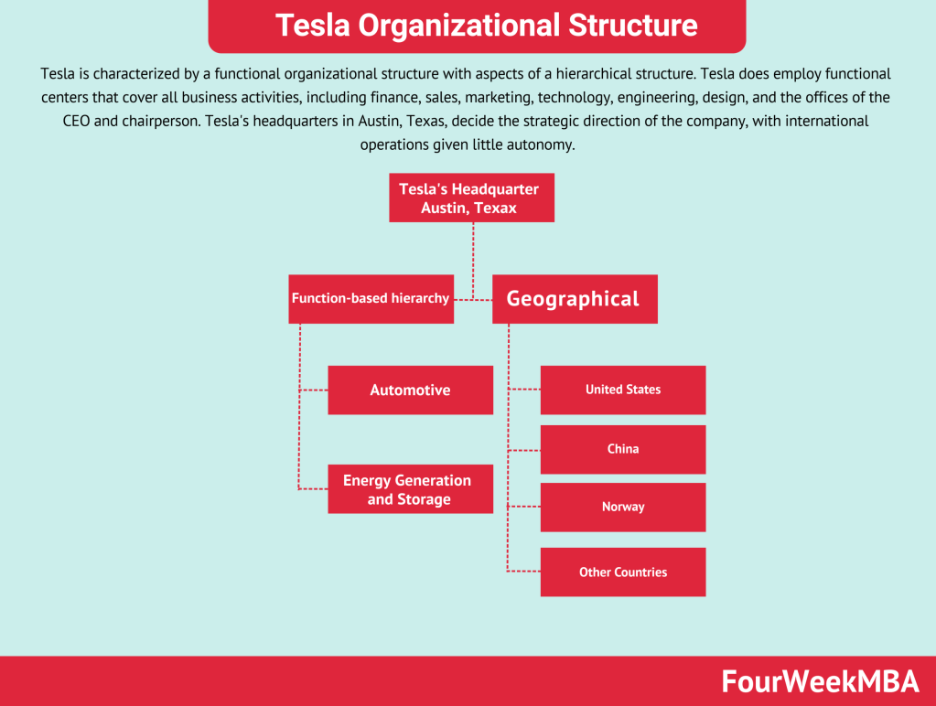

Figure 4. Tesla Organizational Structure (Cuofano, 2024).

Tesla's operations span multiple locations globally, which can create communication barriers due to differences in time zones, languages, and cultural norms. With a hierarchical organizational structure, communication may be restricted to vertical channels which leads to delays in information flow and limited cross-functional collaboration (Vested Team, 2020). Therefore, Tesla can **create more cross-functional teams** for specific projects or initiatives. These teams should include members from different departments to encourage collaboration and communication across functions. It can reduce conflicts and ensure all teams adhere to business objective.

**Improve Risk Management**

Tesla has faced risks during COVID-19 pandemic which caused losses in production, supply, and reputational damage for the company (Tesla, Inc., 2021). Therefore, Tesla should **improve risk management** by systematically identify problems, potential threats and outcomes that could arise from the situation. Specialists must evaluate the urgency and impact to prioritize risks. They should conduct regular reviews and assessments of risk management processes to identify areas for improvement to ensure effectiveness in mitigating risks.

**Invest in Continuous Learning and Development Programs**

Tesla can enhance its workforce's skills and capabilities by **implementing continuous learning and development programs**. These programs can include technical training on new technologies, leadership development initiatives, and opportunities for personal and professional growth. Tesla can empower its workforce to adapt to changing industry trends and stay ahead of the competition. Additionally, these programs can help attract and retain top talent, as employees are more likely to stay with a company that invests in their professional development.

# Conclusion

In conclusion, Tesla's innovative spirit and strategic approach have propelled it to the forefront of the automotive and sustainable energy industries. Its commitment to innovation, investment in technology and research, and fostering a creative work environment have been instrumental in its success. Looking ahead, Tesla should continue prioritizing innovation, investing in its workforce, and enhancing risk management practices to sustain its market leadership and drive the global transition towards electric mobility and renewable energy solutions.

# **References**

Carmely, M. (2022). *Tesla Target Market Analysis & Audience Segmentation | Start.io*. Start.io - a Mobile Marketing and Audience Platform. https://www.start.io/blog/tesla-target-market-analysis-and-segmentation/

Cuofano, G. (2024). *What Is Tesla’s Organizational Structure? Tesla Organizational Structure In A Nutshell - FourWeekMBA*. FourWeekMBA. https://fourweekmba.com/tesla-organizational-structure/#:~:text=Key%20takeaways%3A-,Tesla%20is%20characterized%20by%20a%20functional%20organizational%20structure%20with%20aspects,ratio%20of%20subordinates%20to%20managers.

Gregersen, E., & Schreiber, B. A. (2024). Tesla, Inc. | History, Cars, Elon Musk, & Facts | Britannica. In *Encyclopædia Britannica*. <https://www.britannica.com/topic/Tesla-Motors>

Lambert, F. (2022). *Tesla spends the most R&D and least in advertising per car sold*. Electrek; Electrek. https://electrek.co/2022/03/24/tesla-spends-most-rd-least-advertising-car-sold/

‌Liu, J., & Meng, Z. (2017). (PDF) Innovation Model Analysis of New Energy Vehicles: Taking Toyota, Tesla and BYD as an Example. *ResearchGate*. <https://doi.org/10.1016//j.proeng.2017.01.248>

Qin, K. (2022). (PDF) Analysis of Tesla’s Innovation Strategy and Influence of Leadership. *ResearchGate*. https://doi.org/10.2991//978-94-6463-054-1_26

Reed, E. (2020). *History of Tesla: Timeline and Facts*. TheStreet; TheStreet. <https://www.thestreet.com/technology/history-of-tesla-15088992>

Rowland, C. (2023). *Tesla’s Generic Competitive Strategy & Growth Strategies - Panmore Institute*. Panmore Institute. <https://panmore.com/tesla-motors-inc-generic-strategy-intensive-growth-strategies-analysis#:~:text=Tesla%20uses%20market%20development%20as,establishing%20new%20offices%20and%20facilities>

Schueler, A. (2020). Daimler and its stake in Tesla. Journal of Financial Education, 46(2), 354–369. https://www.jstor.org/stable/48646940

Shao, X., Wang, Q., & Yang, H. (2021). Business Analysis and Future Development of an Electric Vehicle Company--Tesla. *Advances in Social Science, Education and Humanities Research*. <https://doi.org/10.2991/assehr.k.211020.188>

Techsauce Team. (2018, December 14). *How Tesla creates Creative Innovations*. Techsauce; Techsauce.co. <https://techsauce.co/tech-and-biz/how-tesla-creates-creative-innovations>

Tesla. (2020). Diversity, Equity and Inclusion Impact Report 2020 (U.S.). In *Tesla*. https://www.tesla.com/sites/default/files/downloads/2020-DEI-impact-report.pdf

Tesla. (2010). *Strategic partnership: Daimler acquires stake in Tesla | Tesla*. Tesla. https://www.tesla.com/blog/strategic-partnership-daimler-acquires-stake-tesla

Tesla, Inc. (2021). *Quarterly report pursuant to section 13 or 15(d) of the securities exchange act of 1934*. Sec.gov. https://www.sec.gov/Archives/edgar/data/1318605/000095017021000046/tsla-20210331.htm#risk_factors

Trott, P. (2017). *Sixth Edition INNOVATION MANAGEMENT AND NEW PRODUCT DEVELOPMENT*. https://ftp.idu.ac.id/wp-content/uploads/ebook/ip/BUKU%20MANAJEMEN%20INOVASI/Innovation%20Management%20and%20New%20Product%20Development%20(%20PDFDrive%20).pdf

Vested Team. (2020). *Tesla Company - Find Tesla Business & Finance Strategies Analysis*. Vested Finance. https://vestedfinance.com/in/blog/tesla-strategy-analysis/

‌